Experiment-3

Create a simple cloud software application for Car Booking Reservation System using any Cloud Service Provider to demonstrate SaaS.

Aim
To create a simple cloud-based Car Booking Reservation System using Zoho Creator (SaaS) that calculates the total booking amount based on the selected car, number of rental days, and booking type.

Procedure
- Open Zoho Creator.
- Create a new application named Car Booking Reservation System.
- Create a form with the required fields.
- Add a workflow (On Success).
- Write the Deluge script.
- Save and run the application.
- The application calculates the total booking amount and displays the booking details.

Implementation:

customerName = "Mohamed Aseem";
carModel = "Hyundai Creta";
rentalDays = 4;
bookingType = "Self Drive";

rentPerDay = 2500;

totalAmount = rentalDays * rentPerDay;

if(bookingType == "Self Drive")
{
totalAmount = totalAmount;
}
else
{
totalAmount = totalAmount + 1500;
}

info "------ CAR BOOKING DETAILS ------";
info "Customer Name : " + customerName;
info "Car Model : " + carModel;
info "Rental Days : " + rentalDays;
info "Booking Type : " + bookingType;
info "Total Amount : Rs." + totalAmount;
info "Booking Confirmed Successfully";

OUTPUT:

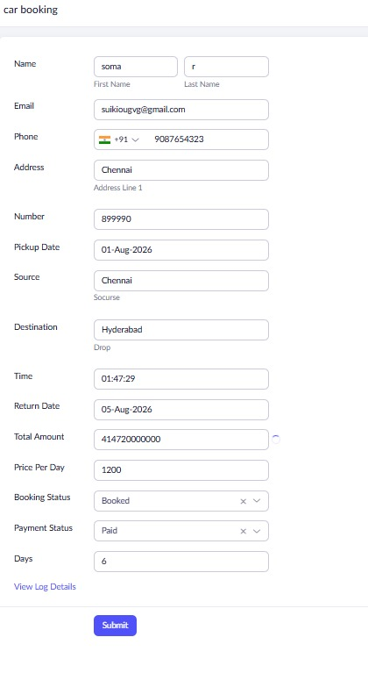

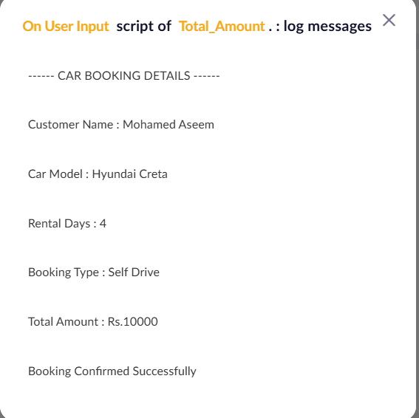

RESULT:
The Car Booking Reservation System was successfully developed using Zoho Creator (SaaS).

